Item name | Item description | Number of face cloths | Colour options
Reindeer - Small | A face cloth rolled into the likeness of a reindeer.  This item comes boxed in clear packaging and contains tinsel pipe cleaner antlers, google eyes, felt ears, pom-pom nose, and ribbon bow.  Can be ordered with or without six mini bath bombs. | 1 | Pink
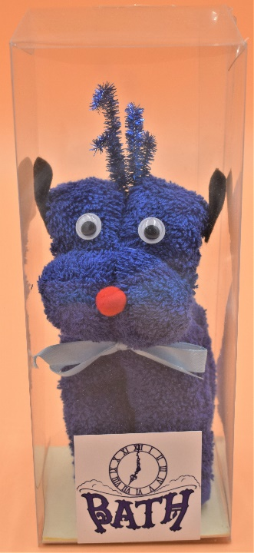 |  | 1 | Navy
 |  | 1 | Teal
 |  | 1 | Wine
 |  | 1 | Cream
 |  | 1 | White
 |  | 1 | Purple
 |  | 1 | Brown
 |  | 1 | Black
 |  | 1 | Grey
Parcel | A face cloth folded into the likeness of a wrapped parcel.  This item comes boxed in clear packaging and contains a ribbon bow.  Can be ordered with or without six mini bath bombs. | 1 | Pink
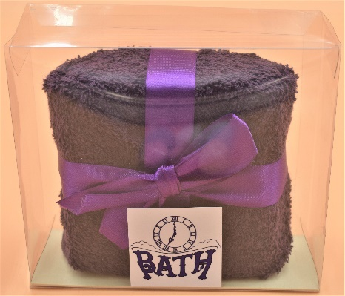 |  | 1 | Navy
 |  | 1 | Teal
 |  | 1 | Wine
 |  | 1 | Cream
 |  | 1 | White
 |  | 1 | Purple
 |  | 1 | Brown
 |  | 1 | Black
 |  | 1 | Grey
Snowman - Small | A face cloth folded into the likeness of a snowman.  This item comes boxed in clear packaging and contains a felt hat, pipe cleaner arms, google eyes, felt carrot nose, pom-poms, and a ribbon scarf.  Please note hats come in assorted colours.  Can be ordered with or without six mini bath bombs. | 1 | White
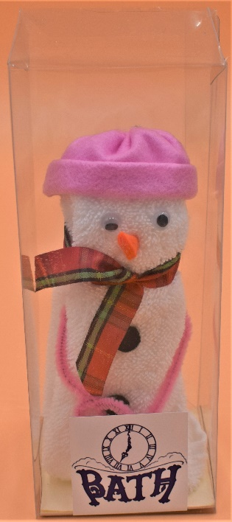 |  | 1 | White

Robin | A face cloth rolled into the likeness of a robin.  This item comes boxed in clear packaging and contains google eyes and felt for the wings, front, feet, and beak.  Can be ordered with or without six mini bath bombs. | 1 | Brown
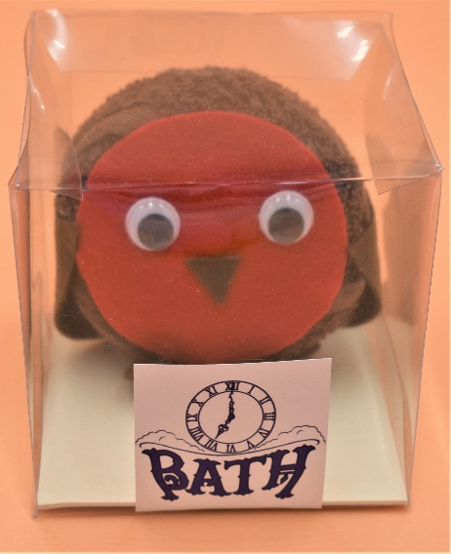 |  | 1 | Brown
Christmas Pudding | A face cloth folded into the likeness of a Christmas Pudding.  This item comes boxed in clear packaging and contains artificial holly decoration.  Can be ordered with or without six mini bath bombs. | 1 | Brown
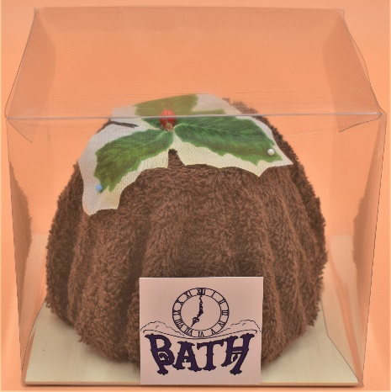 |  | 1 | Brown
Father Christmas | Face cloths folded into the likeness of a Father Christmas stuck in a chimney.  This item comes boxed in clear packaging and contains a felt hat, arms, and snow, google eyes, and pom-pom nose.  Can be ordered with or without six mini bath bombs. | 2 | Red & Black
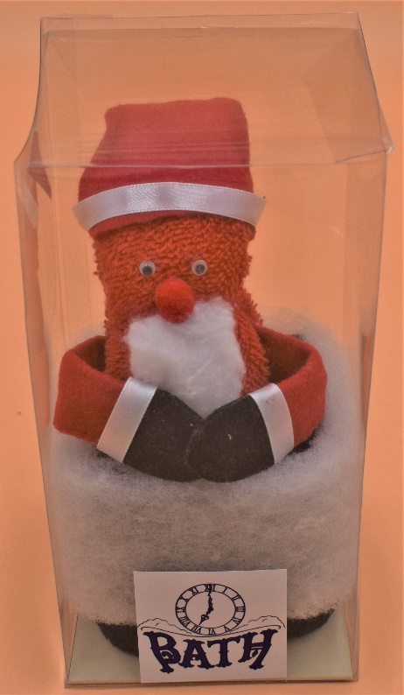 |  | 2 | Red & Black

Father Christmas Legs | Face cloths folded into the likeness of a Father Christmas fallen down the chimney.  This item comes boxed in clear packaging and contains felt boots and snow, with ribbon cuffs.  Can be ordered with or without six mini bath bombs. | 2 | Red & Black
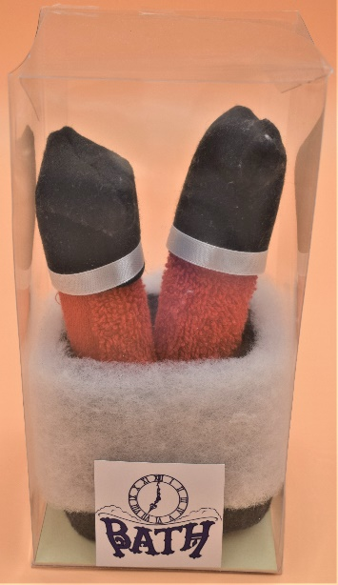 |  | 2 | Red & Black
Penguin | Face cloths rolled into the likeness of a penguin.  This item comes boxed in clear packaging and contains felt front, beak, wings and feet, google eyes, and a ribbon bow.  Can be ordered with or without six mini bath bombs. | 2 | Black
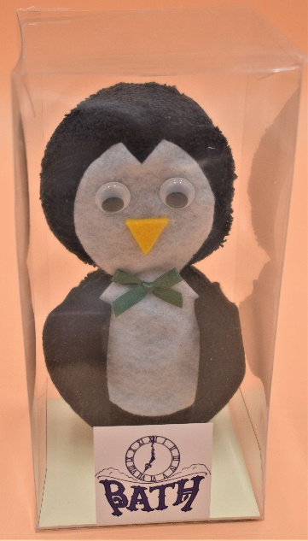 |  | 2 | Black
Chocolate Log - Small | Face cloths rolled into the likeness of a chocolate log.  This item comes boxed in clear packaging and contains artificial holly, and a ribbon bow in assorted Christmas colours.  Can be ordered with or without six mini bath bombs. | 2 | Brown & White
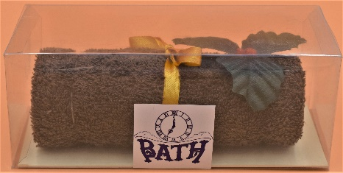 |  | 2 | Brown & White
Christmas Tree | Face cloths rolled into the likeness of a Christmas Tree.  This item comes boxed in clear packaging and contains miniature Christmas lights, pom poms, and tinsel pipe cleaners.  Can be ordered with or without six mini bath bombs. | 3 | Green, Brown & Red
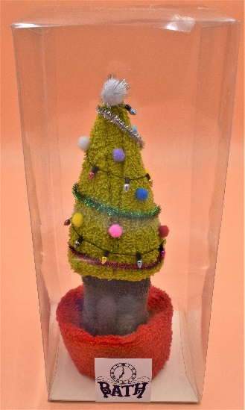 |  | 3 | Green, Brown & Red

Item name | Item description | Number of hand towels | Colour options
Reindeer - Large | A hand towel rolled into the likeness of a reindeer.  This item comes boxed in clear packaging and contains tinsel pipe cleaner antlers, google eyes, felt ears, pom-pom nose, and ribbon bow.  Can be ordered with or without six mini bath bombs. | 1 | Pink
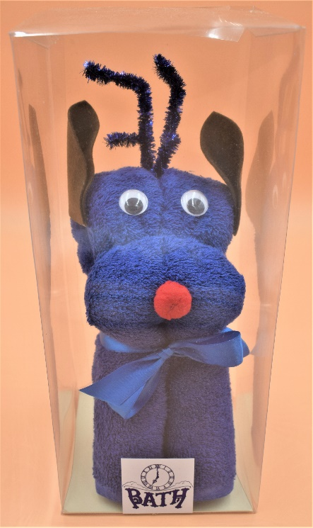 |  | 1 | Navy
 |  | 1 | Teal
 |  | 1 | Wine
 |  | 1 | Cream
 |  | 1 | White
 |  | 1 | Purple
 |  | 1 | Brown
 |  | 1 | Black
 |  | 1 | Grey
Snowman - Large | A hand towel folded into the likeness of a snowman.  This item comes boxed in clear packaging and contains a face cloth hat, pipe cleaner arms, google eyes, felt carrot nose, pom-poms, and a ribbon scarf.  Please note hats come in assorted colours.  Can be ordered with or without six mini bath bombs. | 1 + 1 face cloth | White
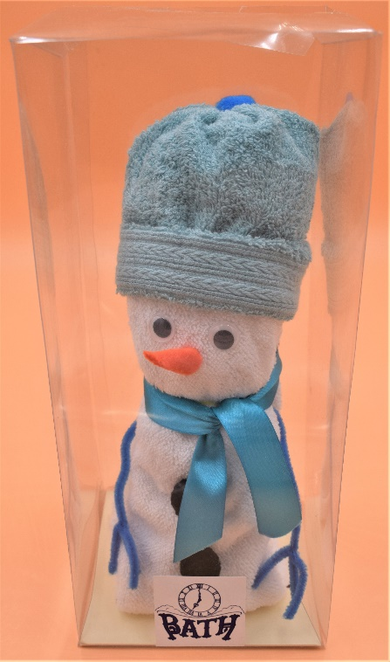 |  | 1 + 1 face cloth | White
Christmas Cake - Small | A hand towel rolled into the likeness of a cake.  This item comes boxed in clear packaging and contains 1 soap rose, a Christmas pick and a ribbon in assorted Christmas colours. | 1 | White
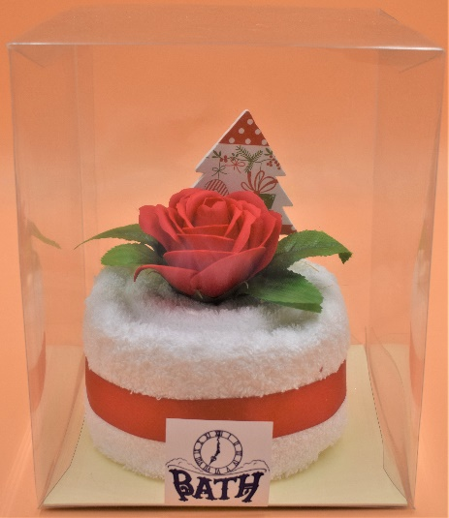 |  | 1 | White
Christmas Cake - Large | Hand towels rolled into the likeness of a cake.  This item comes boxed in clear packaging and contains soap flowers, a Christmas pick and a ribbon in assorted Christmas colours. | 2 | White
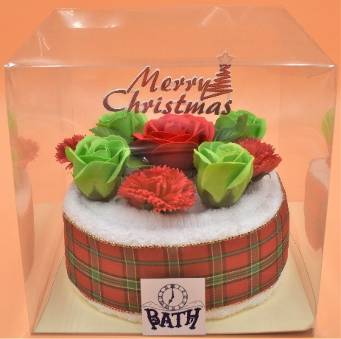 |  | 2 | White
Chocolate Log - Large | Hand towels rolled into the likeness of a chocolate log.  This item comes boxed in clear packaging and contains soap flowers, a Christmas pick and a ribbon in assorted Christmas colours. | 2 | Brown & White
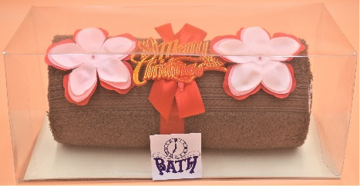 |  | 2 | Brown & White

Item name | Item description | Number of bath towels | Colour options
Christmas Cake - XL | A bath towel rolled into the likeness of a cake.  This item comes boxed in clear packaging and contains 1 face cloth reindeer in assorted colours, soap flowers, a Christmas pick and a ribbon in assorted Christmas colours. | 1 + 1 face cloth | White
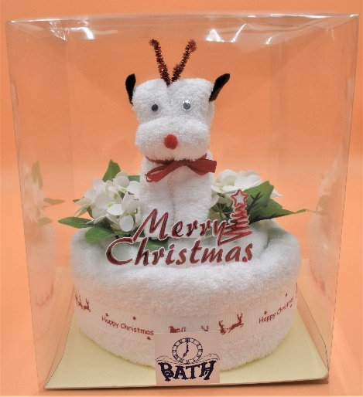 |  | 1 + 1 face cloth | White

